Project Documentation

Cook Book : Your Virtual Kitchen Assistant

# Introduction

## Project Title : Cook Book

**Team ID :** NM2025TMID47754

* + **Team Leader:** V.Boomika & [boomidaru@gmail.com](mailto:boomidaru@gmail.com)

## Team Members:

* + - L.Aswini & [laswini009@gmail.com](mailto:laswini009@gmail.com)
    - S.Deepika & [deepikasamraj317@gmail.com](mailto:%20deepikasamraj317@gmail.com)
    - R.Deepika & [deepikaramesh2404@gmail.com](mailto:%20deepikaramesh2404@gmail.com)

# Project Overview

**Purpose:** The **purpose of a cookbook** is to provide **instructions, guidance, and inspiration** for preparing food and beverages. More specifically, a cookbook serves several key purposes.

## Features:

* + - **User-Friendly Experience**
    - Preservation of Recipes
    - Meal Planning and Nutrition
    - Inspiration and Creativity
    - **Cultural Education**
    - **Professional Reference**

# Architecture

* + **Frontend:** The **frontend** is what the user sees and interacts with — the **user interface** of your cookbook app or website.
  + **Backend:** The **backend** handles the data, logic, storage, and communication between the frontend and the database.

**Database:** It's the **structure and relationships** between the data in your cookbook — including **recipes, users, ingredients, categories, images**, etc. A well-designed database makes your app:

* Fast
* Scalable
* Easy to maintain
* Able to support features like search, filtering, and saving favorites

# Setup Instructions

## Prerequisites:

**Node.js and npm**

**React.js**

**HTML, CSS, and JavaScript**

**Version Control**

**Development Environment**

## Installation Steps:

**Install Dependencies:**

• Navigate into the cloned repository directory and install libraries:

cd fitness-app-react

npm install

* **Start the Development Server**:

• To start the development server, execute the following command:

npm start

**Access the App:**

• Open your web browser and navigate to [http://localhost:3000](http://localhost:3000/).

• You should see the application's homepage, indicating that the installation and setup were successful.

# Folder Structure

cookbook-project/

│

├── 📄 README.md # Project overview or instructions

├── 📄 cookbook.md / .docx / .tex # Main book file (Markdown, Word, LaTeX, etc.)

├── 📁 recipes/ # All individual recipes

│ ├── breakfast/

│ │ ├── pancakes.md

│ │ └── omelette.md

│ ├── lunch/

│ │ ├── caesar-salad.md

│ │ └── grilled-cheese.md

│ ├── dinner/

│ │ ├── lasagna.md

│ │ └── curry.md

│ └── desserts/

│ ├── brownies.md

│ └── cheesecake.md

│

├── 📁 images/ # Recipe and step-by-step images

│ ├── breakfast/

│ ├── lunch/

│ └── dinner/

│

├── 📁 assets/ # Fonts, styles, templates, icons

│ ├── styles.css # For web or PDF formatting

│ └── fonts/

│

├── 📁 extras/ # Supporting content

│ ├── pantry-list.md

│ ├── measurement-guide.md

│ ├── substitutions.md

│ └── glossary.md

│

├── 📁 output/ # Final exported versions

│ ├── cookbook.pdf

│ ├── cookbook.epub

│ └── cookbook.html

│

└── 📁 scripts/ # Automation scripts (optional)

└── build.sh # Script to generate final book

# Running the Application

## Frontend:

## cd cookbook/frontend

## npm install # install frontend dependencies if needed

## npm start # start the frontend dev server (usually `http://localhost:3000`)

• **Backend:**

cd cookbook/backend

npm install # install dependencies if not done yet

npm start # or your backend start command (like `node server.js`)

* + **Access:** Visit [http://localhost:3000](http://localhost:3000/)

# API Documentation

## User:

-http://localhost:3000/api/users or <https://api.cookbookapp.com/api>

- [boomidaru@gmail.com](mailto:boomidaru@gmail.com)

## Projects:

? Setup the Routing paths

Setup the clear routing paths to access various files in the application.

? Develop the Navbar and Hero components

? Code the popular categories components and fetch the categories from ***themealsdb*** Api.

? Also, add the trending dishes in the home page.

? Now, develop the category page to display various dishes under the category.

? Finally, code the recipe page, where the ingredients, instructions and a demo video  will be integrated to make cooking much easier.

# Authentication

To allow users to **create accounts**.

To let users **log in** and access personalized features (like saving favorite recipes).

To **secure** user data and prevent unauthorized access.

# User Interface

* + Landing Page
  + Freelancer Dashboard
  + Admin Panel
  + Project Details Page

# Testing

* + Manual testing during milestones
  + Tools: Postman, Chrome Dev Tools

1. **Screenshots or Demo**

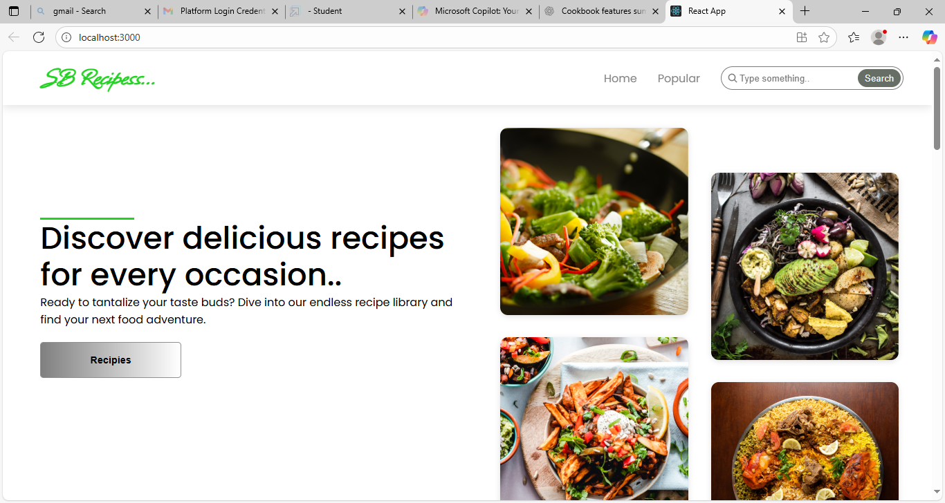

**Trending Dishes**

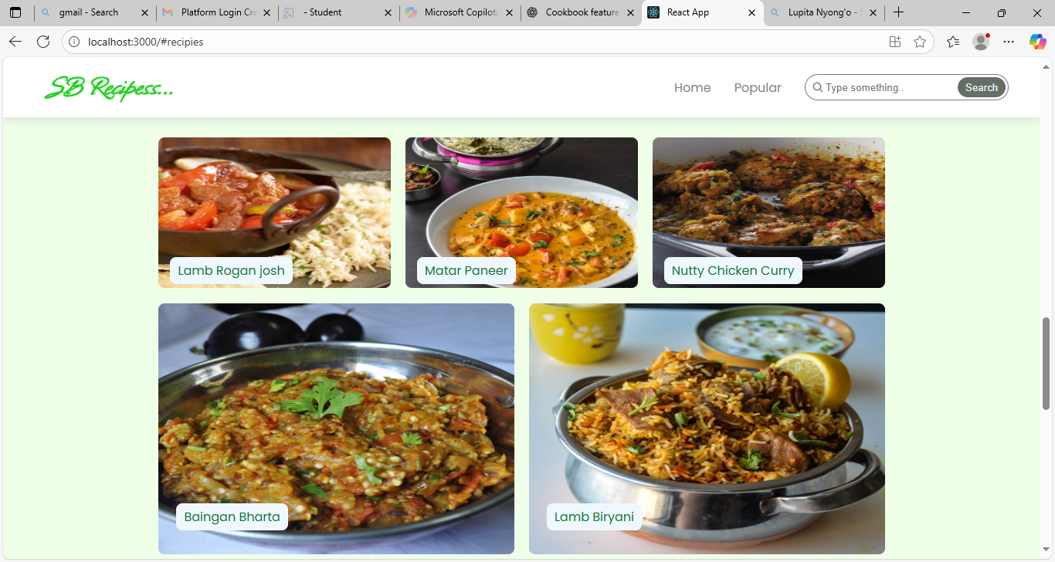

1. **Future Enhancements**

🔍 **Advanced Search and Filtering**

🧠 **AI-Powered Recipe Suggestions**

.🎥 **Video Recipes**